**Experiment 8**

**Aim:**

To write an ARM Assembly Language program for division using repeated subtraction.

**Tool Used:**

Keil uVision4

**Theory:**

LDR loads the register with some value. One register can be used as a counter. The first number can be subtracted by second number. On every loop the counter register is incremented on to the result.

**Code:**

 AREA PROGRAM, CODE, READONLY

 ENTRY

MAIN

     LDR R0, =0X00001000

     LDR R1, =0X00001004

     LDR R4, =0X00001008

     LDR R6, =0x0000100C

     LDR R2, [R0]

     LDR R3, [R1]

LOOP

        SUB R2, R2, R3

        ADD R5,R5,#1

        CMP R2,R3

        BGE LOOP

        STR R5, [R4]

        STR R2, [R6]

LOOP1   B LOOP1

        END

**Output:**

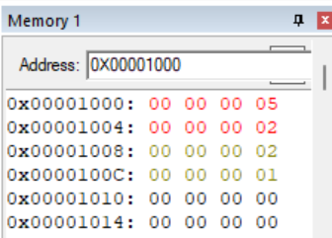

Dividend Location – 0x00001000

Divisor location - 0x00001004

Quotient location – 0x00001008

Remainder Location – 0x0000100C

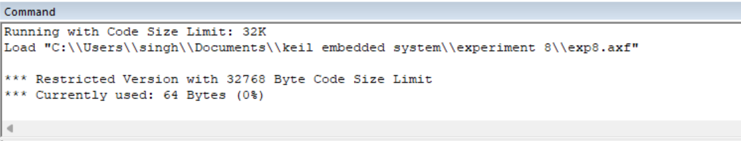

**Register Content**

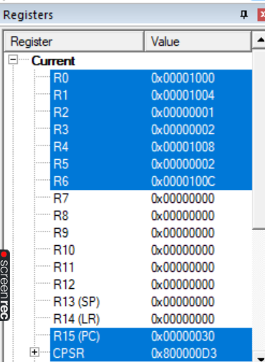

**Result:**

The experiments on Division operation using repeated subtraction have been performed and verified to be correct.